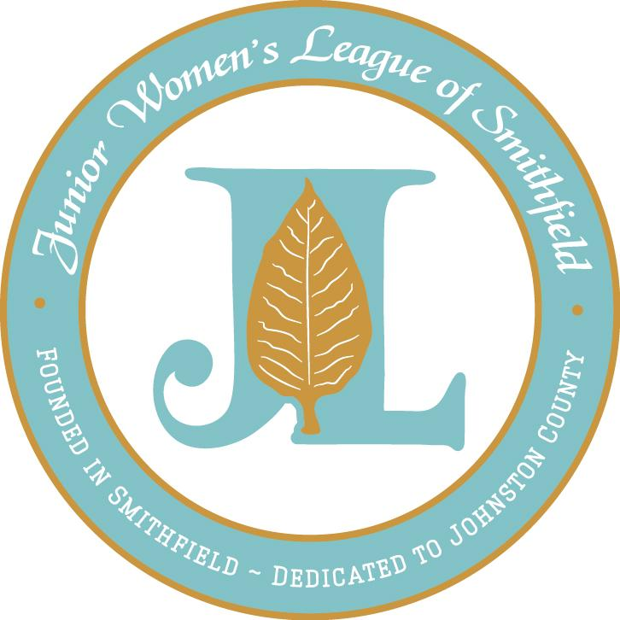

Dear Friend of the League:

In 2017, 1219 children in Johnston County were impacted by domestic violence and sexual assault. Although no child should have to endure this trauma, it is essential that there are services available to these children to help them move beyond a life of violence. It is for this reason that the Junior Women’s League of Smithfield has selected Harbor of Johnston County as the recipient of our Community Impact Grant, which is supported by our signature Big Night Out fundraiser.

Harbor will utilize the funds raised by Big Night Out to help fund a child advocate position, which will allow them to provide additional services to children who have been traumatically impacted by both domestic violence and sexual assault. The funds granted will make those efforts not only come to fruition but also place Harbor on the right path to ensure that those children who they serve are given every opportunity to begin their personal healing process.

We ask for your support for this important work as a sponsor of JWL’s Big Night Out, scheduled for Friday, June 1st at The Farm at 42. With entertainment by The Embers, it is sure to be a fun night with a big crowd eager to support a great cause. We would be honored for you to consider being a sponsor! Should you wish to support Big Night Out in a different way, you can purchase tickets to attend the event or donate an item for our silent auction.

You will not want to miss the opportunity to participate in one of the most memorable and rewarding events of the year! Please browse the enclosed sponsorship opportunities to find the level that is most fitting for you or your business. You can return the completed sponsorship form via email to jwlsmithfield@gmail.com or mail your completed form to JWL’s Big Night Out, PO Box 1272, Clayton, NC 27528. In order to provide the full benefits detailed, the sponsorship deadline is May 1st. If you have questions regarding the sponsorship opportunities, please email us at jwlsmithfield@gmail.com.

On behalf of the Junior Women’s League of Smithfield and the children and families who will benefit from the assistance provided by Harbor of Johnston County, we thank you for your support of Big Night Out.

Warmest Regards,

Meredith Fordham
2017-2018 President
Junior Women’s League of Smithfield
jwlsmithfield@gmail.com

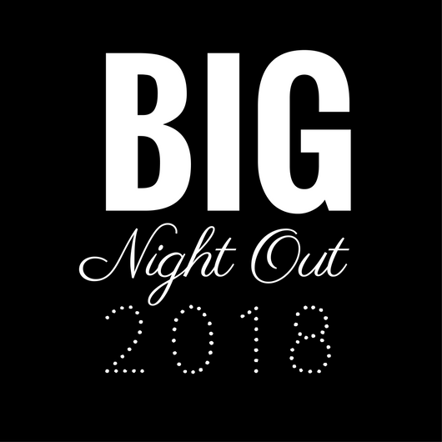
June 1st, 2018

Sponsor Company Name: ______________________________________________________________
Sponsor Contact Name: ________________________________________________________________
Address: _______________________________________________________________________________
City: _______________________________ State: ____________ Zip: ____________________________
Phone Number: _________________________ E-Mail: ______________________________________
Sponsorship Level: _____________________________________________________________________

SPONSORSHIP INFORMATION

DIAMOND - $2,000 8 event tickets; 8 specialty drink tickets; Premium seating- table for 8 with table side service for dinner; Premium parking at the event; Exclusive placement of logo on event materials- including red carpet entrance photo background, website, social media advertisements and event T-shirts; Recognition at the event from the podium and on signage/monitors; Pre-silent auction viewing from 7:00pm-7:30pm with first chance on bidding.

PLATINUM - $1,000 4 event tickets; 4 specialty drink tickets; Corporate Logo on website and event materials- including red carpet entrance photo background, social media advertisements and event T-shirts; Recognition at the event from the podium and on signage/monitors.

GOLD - $500 2 event tickets; 2 specialty drink tickets; Corporate logo included in social media advertisements and on event T-shirts.

SILVER - $250 Corporate logo included in social media advertisements and day of event signage.

Name of JWL Member who solicited your sponsorship (if applicable):_______________________

Additional BIG NIGHT OUT event tickets available at $65 per person. Tickets can be purchased at www.jwlsmithfield.com

Registration forms and corporate logos can be e-mailed or mailed.
JWL’s Big Night Out
PO Box 1272
Clayton, NC 27528
jwlsmithfield@gmail.com
Make checks payable to Junior Women’s League of Smithfield.

